Experiment: SILLY PUTTY
Ever wondered what the amazing stretchy toy in a plastic egg is made of? Yes, silly putty happily deforms when stretched slowly, but when you pull it apart with enough force, it snaps in two!
This product is one of the many accidently invented polymers during World War II. James Wright, an engineer, was aiming to create synthetic rubber at a company called General Electric in Connecticut. He noticed something unusual in his experiments when he combined Boric Acid and a flexible silicone polymer that led to this interesting gob of goo!
Silly Putty Chemistry
Silly putty is made from covalently bonded polymers or long chains of monomers. Widely known as PDMS (Polydimethylsiloxane), this material is made up of a silicone containing polymer with silicon (Si) and oxygen (O) atoms bonded together, or long chains of Si-O-Si linkages in the backbone. PDMS is a soft viscoelastic polymer. This means it can flow like a liquid in some cases and act like solid in other cases. Almost 65% of Silly Putty consists of PDMS, which explains Silly Putty’s varying mechanical properties at different time scales. Here, different time scales can be short times (holds the shape like a solid when you are actively playing with material) and longer times (flows and takes the shape of the container over time). Figure below shows the structure of PDMS.
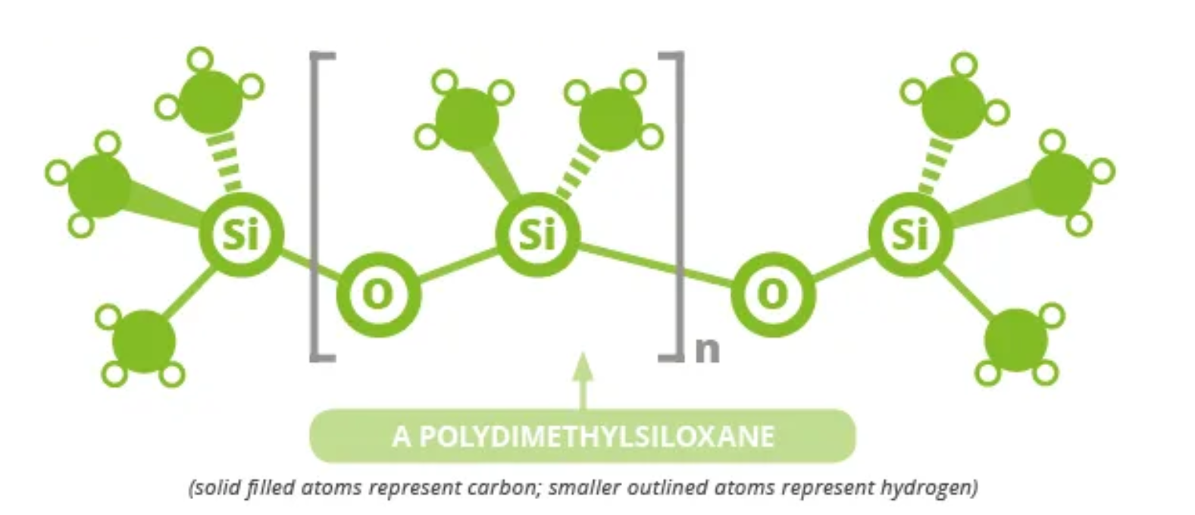
Figure 1. The above cartoon polymer structure represents the structure of PDMS. Notice the Si-O linkages along the polymer backbone.
When a polymer chain is connected to another polymer chain using a “bridge”, it leads to a network in polymer systems. A collection of such networks is known as a crosslinked polymer. In Silly Putty, the bridge is made from Boric Acid (a small molecule) that connects to PDMS chains via hydrogen bonding (Yes, the same bond that is found to connect water molecules!)
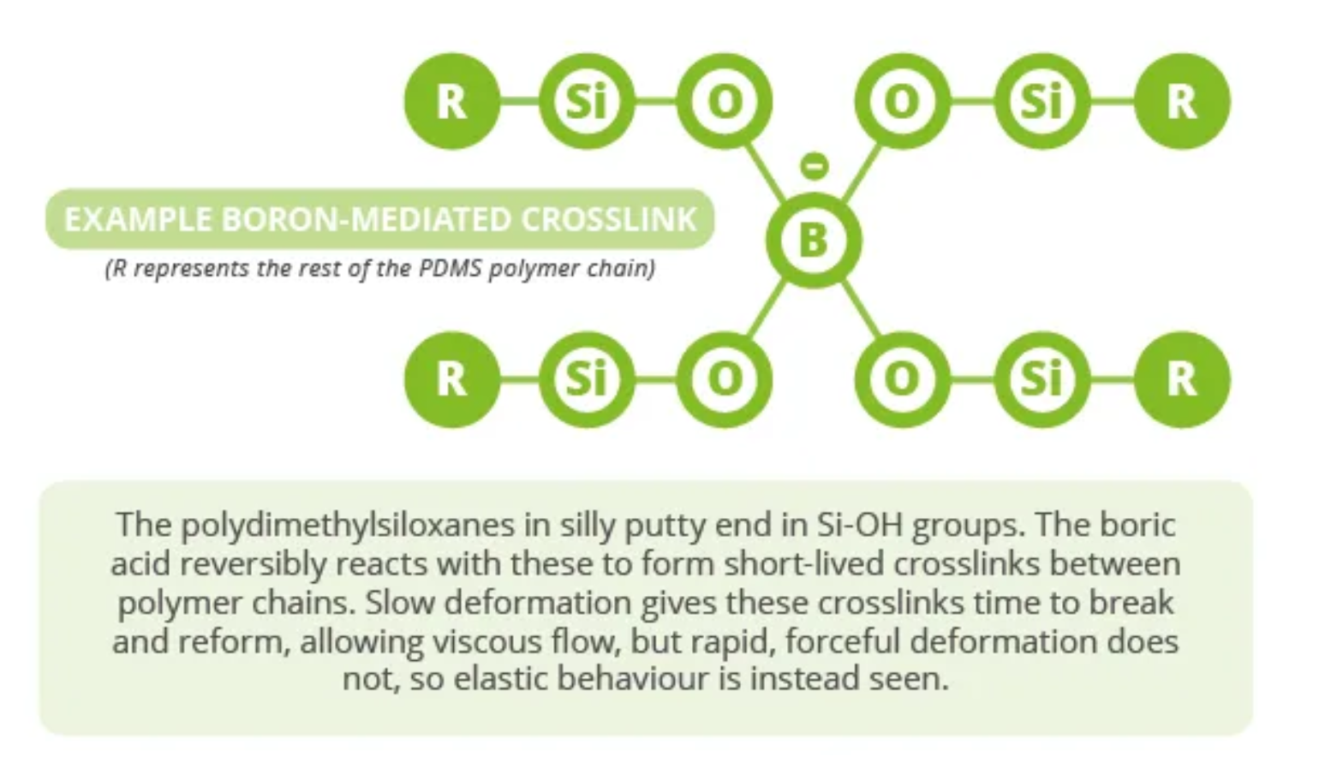
Figure 2. The above cartoon polymer structure represents the chemical structure of silly putty. The boric acid acts as a “bridge” between polymer chains to connect the chains into a network.
These bonds are transient in nature, meaning they can change over time. Hence, when the putty is slowly stretched, the crosslinks have time to break and reform at different parts of the polymer chain, showing the viscous properties of putty. However, when the putty is stretched with a considerable force, the cross links do not have time to break and reform, then the elastic behaviour is seen.
Interesting Applications
Pothole Patch:
Filling potholes with asphalt is very time consuming! A silly putty filled waterproof sac solves this problem temporarily. It can easily accommodate into the shape of the pothole when compressed gently due to its fluid-like behavior. Whereas retain its shape and behave solid-like when any vehicle runs over.
Zero Gravity Adhesive:
Silly Putty can be made responsive to magnets by the addition of magnetic Iron Oxide Particles. Can you imagine how the magnetic putty will behave in the presence of a magnet?
The magnetic silly putty was used as adhesive by astronauts in the Apollo Mission to hold the tools in place under zero gravity!
Materials Provided
- Silly Putty
- Safety Glasses

Safety Precautions
There are no hazards from normal handling of Silly Putty. Do not ingest and use only in the manner for which it is intended. Wash hands thoroughly after handling. Wear Safety glasses during the experiments.
Experiments
The Stretch and Tear
Stretch the silly putty block slowly with both hands. What does it look like? Now remold this silly putty into a sheet, pinch on one edge and quickly tear the sheet with both hands. Do you notice any difference in the putty’s behaviour?
The Bounce
Roll the putty into a ball and drop it on a clean and flat surface. It will bounce like a regular ball. You can drop it from different heights and note if there is any change in their bouncing patterns.
Place the ball inside the freezer for a couple of hours or place it outside during winter, and then drop it on the counter. Wear safety glasses to protect your eyes from the flying pieces of putty. How does the elastic behaviour change under cold conditions?
Try heating the putty with a hair dryer and roll it quickly into a ball and observe the bounce. Is there any difference between warm putty and cold putty? Why is it so?
The Shatter
Parents discretion required. Wear Safety glasses to protect your eyes. Place the putty on a concrete (preferably outside) and smash it with a hammer. Does it smash into two or more pieces?

