Experiment: WETTING 101
Is “wet” an adjective or a verb? It’s both! When we describe something as “wet”, it is either covered with water or it has absorbed water. “Wet” can also be a verb. We can say that water will “wet” a surface, or will spread out to make a puddle or a water film. Or we might say that water will not “wet” a surface, meaning that the water will bead up into droplets to minimize the water contact with the material surface.

We can classify different material surfaces by their “wetting properties”. These properties describe whether water will spread out or bead up when it touches the surface. When water spreads out, the surface is “hydrophilic” or water (hydro-) loving (-philic). This material is said to have high surface energy. When water beads up, the surface is “hydrophobic” or water (hydro-) fearing (-phobic). This surface is said to have low surface energy.

To determine the wetting properties of a material, you can simply place a drop of water on the material’s surface and observe the behavior of the water. To make research measurements in a laboratory, a very good camera is connected to a computer with special software. The camera records a close-up image of the shape of the water droplet on the surface and the software measures the water contact angle. If the angle is greater than 90, the surface is considered hydrophobic. If the angle is smaller than 90, the surface is considered hydrophilic.

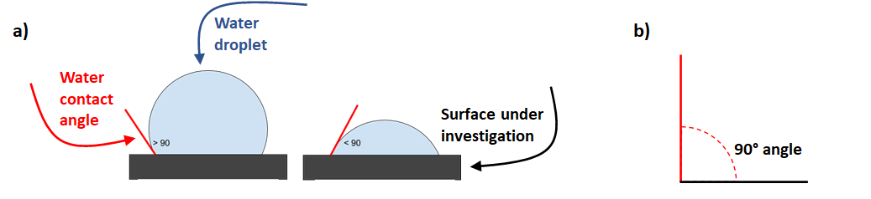
Figure 1. a) The side view of a hydrophobic surface is shown on the left and a hydrophilic surface on the right. b) For reference, a 90 angle makes the corner of a square.

There are two reasons for the behavior of water on materials surfaces with different surface energy. Any guesses?

- Chemical Structure. If we consider the chemical structure of a material, we can make a hypothesis about how a water droplet will behave on its surface. Water (H₂O) is called a “polar” molecule because the oxygen atom is very electronegative, it pulls electrons toward itself creating a partial negative charge, sort of like a “positive pole” and a “negative pole” at each side of the molecule. Polar materials will also have this type of charge separation to some extent. Water will wet a polar surface, spreading out and decreasing the water contact angle. Many polymer molecules like polyethylene (plastic grocery bags), polypropylene (Ziploc bags), or polystyrene (Solo cups), are composed of mainly carbon and hydrogen atoms, and do not have significant charge separation. These materials are “non-polar”. Water does not wet non-polar materials well, if at all. If we picture a plastic grocery bag, does it keep our groceries dry when it rains?

- Physical structure. Understanding the physical structure at the surface of a material also allows us to make a prediction about how water might behave. Roughness, or microscopic hills and valleys at the material’s surface, are very difficult to wet because air gets trapped between the microstructures decreasing the contact between the water and surface. This allows water to bead up and the droplets to roll off the surface. This is known as the “lotus effect” or the “self-cleaning” phenomenon seen on lotus flower leaves. Lotus plants, found in swamps, are superhydrophobic and water droplets roll right off carrying away dirt and debris covering the leaves. This self-cleaning phenomenon prevents dirt from blocking out sunlight and stopping photosynthesis, necessary for plant growth.

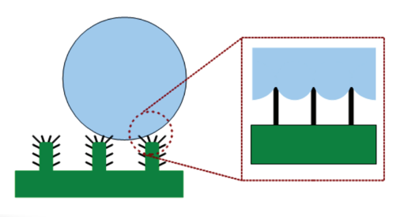
Figure 2. a) Hierarchical surface roughness, shown as larger green posts and smaller black posts, creates air gaps between the water and the surface causing the water to bead up.

Another example of strategic wetting properties found in nature is the Stenocara beetle of the Namib Desert in Africa. This beetle combines both chemical and physical structure to collect water. The insect’s back and wings have hydrophilic bumps that encourage condensation and can capture water from fog. These bumps are surrounded by hydrophobic troughs (or valleys), in which the water beads up into droplets. The droplets roll down the troughs and the water is funnelled to the beetle’s mouth — allowing it to survive in one of Earth’s driest places.

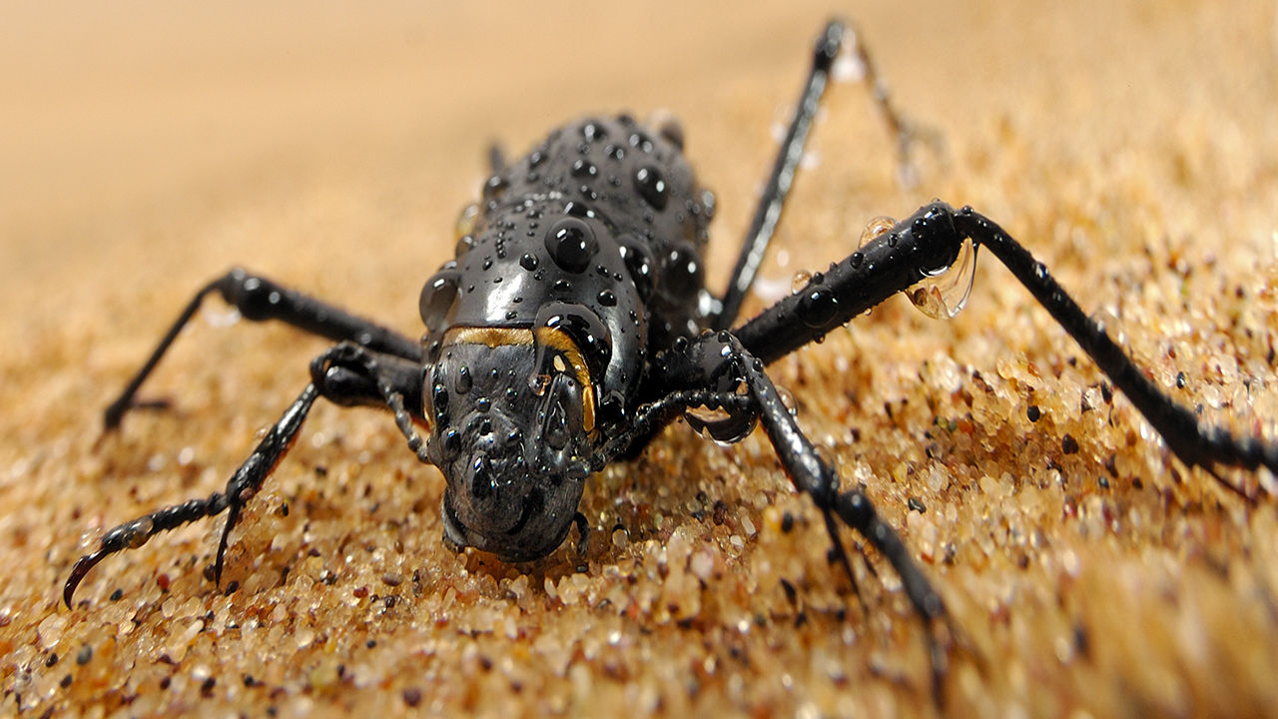

Figure 3. The Stenocara beetle collects water on its back to drink and stay hydrated. Image from 2019 Science magazine article: Could this desert beetle help humans harvest water from thin air?

Materials:
Plastic transfer pipet
Polytetrafluoroethylene square (PTFE or Teflon)
Ziploc polypropylene bag
Paper towels
Marking crayon
Sandpaper square

Directions:
- Think about what paper towels are used for. What do you think will happen when you drop water onto the paper towel? Use the plastic pipet to drop water on a paper towel. What does the water do? What can we say about the wetting properties of paper towels? Is this beneficial for their use?
- Draw a thick line using the marking crayon on a dry portion of paper towel. What do you think will happen when you drop water onto the crayon coated paper towel? What are crayons made of? Use the plastic pipet to drop water on the crayon mark on the paper towel. What does the water do? What can we say about the wetting properties of the crayon? OPTIONAL: Try taking a close up picture of the water droplet on the crayon coated paper from the side view with a cell phone. Does the water contact angle look like it is less than or greater than 90?
- We know that many polymer materials are “non-polar” and may likely be “hydrophobic”. You have two different polymer materials in your kit. Ziploc bags are made from a polymer called polypropylene. Based on the common use of plastic bags, what do you think will happen when the water contacts the polymer surface? Use the plastic pipet to drop water on the Ziploc bag. What happens? Polytetrafluoroethylene or Teflon is used to make non-stick coatings for pans. It is a special polymer that is made of carbon and fluorine instead of carbon and hydrogen. What do you think will happen when water contacts the Teflon surface? Use the plastic pipet to drop water on the Teflon. Is the shape of the water droplets on the Teflon surface different from the polypropylene surface? What can we say about the wetting properties of these polymers. OPTIONAL: Try taking a close up picture of the water droplet on the polymer surface from the side view with a cell phone. Do the water contact angles look like they are less than or greater than 90? Is the contact angle the same for the Ziploc bag vs the Teflon surface?
- You can also change the roughness of a surface to affect its wetting properties. Use the sandpaper to gently roughen the surface of the teflon square. Now drop water onto it again. What happens? How did we change the surface of the Teflon?

